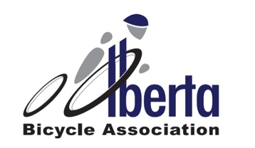

Request for Upgrade

Please be advised that upgrade requests must be received no less than 7 days prior to the race for which the upgrade is being requested. Please forward this completed request to James Kendal at jkendal@albertabicycle.ab.ca

Name:
Coach Name:
Discipline:
Current Category:
Current Points:
Requesting Category:
Top 3 Last Season Race Results: | (please include the link to the results)
Top 3 Current Season Race Results: | (please include the link to the results)
Reason for wanting upgrade:

Road Racing Upgrade Policy

Cyclo-Cross Upgrade Policy

MTB Upgrade Policy

Track Upgrade Policy

